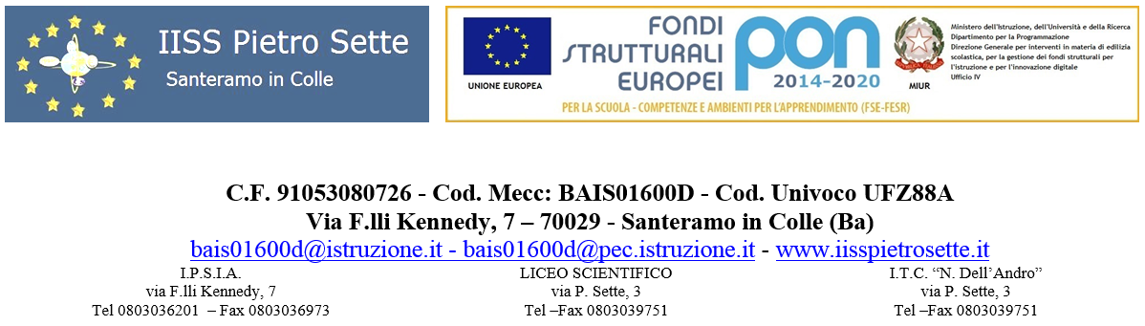

INGLESE

PROGRAMMA SVOLTO **Classe I B LSA**

Prof.ssa Lopane Alessandra

a.s. 2023/2024

|  |
| --- |
| **MODULO N. 1**  STARTER |

|  |  |
| --- | --- |
| **Abilità e Competenze**  Reading  Listening  Speaking  Writing | **Conoscenze**  Funzioni comunicative  Grammatica: Be (all forms), subject pronouns and possessive adjectives, possessive ‘s and possessive pronouns, have got, plural nouns, this/that/these/those, question words, there is/there are, a/some/any, countable and uncountable nouns, a/some/any, much/many/lots of/a lot of, can, the imperative, object pronouns.  Aree lessicali: family, school subjects,days, months, the time, propositions of time, food and drink, numbers and dates, free-time activities. |

|  |
| --- |
| **MODULO N. 2**  UNIT 1: OUR HABITS |

|  |  |
| --- | --- |
| **Abilità e Competenze**  Reading activities proposed in the Unit  Listening activities proposed in the Unit  Speaking:  Habits  Writing:  Informal first contact | **Conoscenze**  Funzioni comunicative:  Greeting and introducing  Grammatica:  Present simple affermative and negative. Present simple questions. Frequency adverbs and expressions  Aree lessicali:  At home. Everyday activities |

|  |
| --- |
| **MODULO N. 3**  UNIT 2: WHAT MAKES US HAPPY |

|  |  |
| --- | --- |
| **Abilità e Competenze**  Reading activities proposed in the Unit  Listening activities proposed in the Unit  Speaking:  Online hobbies  Writing:  Social media profile writing | **Conoscenze**  Funzioni comunicative:  Agreeing and disagreeing  Grammatica:  Present continuous, verbs of preference, present simple vs present continuous  Aree lessicali:  Free time activities, entertainment |

|  |
| --- |
| **MODULO N. 4**  UNIT 3: HEALTH MATTERS |

|  |  |
| --- | --- |
| **Abilità e Competenze**  Reading activities proposed in the Unit  Listening activities proposed in the Unit  Speaking:  Starting strong  Writing:  Forum Post | **Conoscenze**  Funzioni comunicative:  Eating out  Grammatica:  Quantities, requests and offers, excessive/(in)sufficient quantities  Aree lessicali:  Nutrition, health |

|  |
| --- |
| **MODULO N. 5**  UNIT 4: HOW WE SHOP |

|  |  |
| --- | --- |
| **Abilità e Competenze**  Reading activities proposed in the Unit  Listening activities proposed in the Unit  Speaking:  Shopping centres  Writing:  Historical biography | **Conoscenze**  Funzioni comunicative:  Buying clothes  Grammatica:  Past simple be all forms, past simple regular verbs, past simple irregular verbs  Aree lessicali:  Clothes, in shops and online |

|  |
| --- |
| **MODULO N. 6**  UNIT 5: TRIPS AND TRAVEL |

|  |  |
| --- | --- |
| **Abilità e Competenze**  Reading activities proposed in the Unit  Listening activities proposed in the Unit  Speaking:  Map apps  Writing:  Story | **Conoscenze**  Funzioni comunicative:  Using public transport  Grammatica:  Past continuous, past simple and past continuous, past simple vs past continuous  Aree lessicali:  Public transport, getting around |

|  |
| --- |
| **MODULO N. 7**  UNIT 6: WE’RE ALL DIFFERENT |

|  |  |
| --- | --- |
| **Abilità e Competenze**  Reading activities proposed in the Unit  Listening activities proposed in the Unit  Speaking:  Popularity  Writing:  Reply to an invitation | **Conoscenze**  Funzioni comunicative:  Inviting, accepting and refusing  Grammatica:  Comparative adjectives, less + adjective, (in)equality (not) as + adjective + as, superlative adjectives, the least + adjective  Aree lessicali:  Personality, feelings |

|  |
| --- |
| **MODULO N. 8**  UNIT 7: IN CLASS OR ONLINE? |

|  |  |
| --- | --- |
| **Abilità e Competenze**  Reading activities proposed in the Unit  Listening activities proposed in the Unit  Speaking:  Exam success  Writing:  Blog entry | **Conoscenze**  Funzioni comunicative:  Instructing  Grammatica:  Should for advise, must/have to for obligation, mustn’t/don’t have to, needn’t  Aree lessicali:  Education, at school |

|  |
| --- |
| **MODULO N. 9**  UNIT 8: THE WORLD OF WORK |

|  |  |
| --- | --- |
| **Abilità e Competenze**    Reading activities proposed in the Unit  Listening activities proposed in the Unit  Speaking:  Student workers  Writing: | **Conoscenze**  Funzioni comunicative:  Job interview  Grammatica:  Future intentions: be going to, future offers: will/shall.  Aree lessicali:  Jobs, work |

E’ stato proposta la visione in lingua inglese del film: ‘A Christmas Carol’ con attività di comprensione. Ulteriori attività di listening sono state svolte in laboratorio linguistico sulla piattaforma Voicebook.

Testi utilizzati: **Both Sides A2 B1,** Student’s book and workbook, Cambridge; **Get Inside Grammar**, Il Pentagono.

Santeramo, 7/06/2024

La docente Gli Alunni

F.to **Lopane Alessandra**